**DOCUMENTATION FOR SUPERSTORES SALES DASHBOARD**

The dataset in an excel workbook (named Superstore Normalized) was downloaded from this Github URL https://aka.ms/30DLDATGitHubRepo and imported onto Power BI desktop (Power query editor) for onward cleaning and transformation.

The normalized dataset has 5 tables: Customer, Sales, Sales Reps, Locations and Products. For data cleaning on power query, I used first row as header for the customer table. Then I closed and applied onto Power BI to proceed with the analysis and visualization.

In the model pane on Power Bi, each of the dimensions table was connected to the Sales table (facts table) by clicking and dragging the key elements from each of the dimensions table into the sales table.

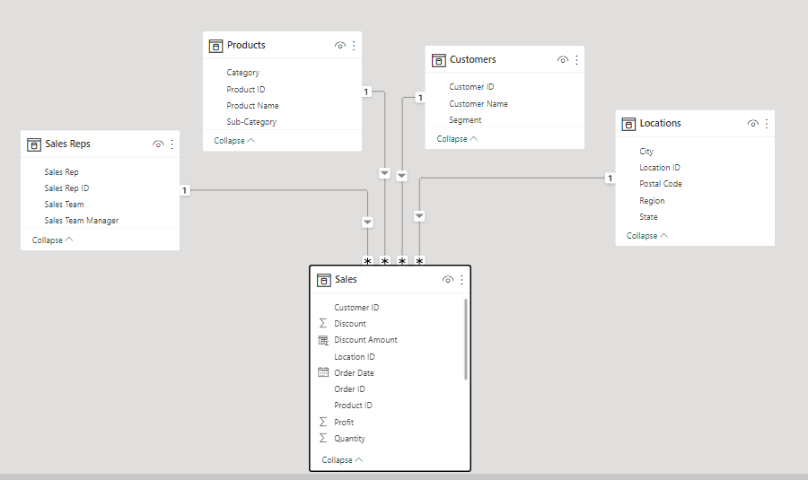

**DAX** which means Data Analysis Expressions was used in creating some measures (on demand) used in the analysis with functions such as *RELATED* (which returns a value from a different table into another table since both tables have a relationship in the data model); *SUMX* (which returns the sum of an expression evaluated for each row in a table) alongside *FILTER* (which returns a table that has been filtered), etc.

The dashboard below was then built to convey the insights drawn from the data to show:

Total number of products, Sales by region, Top 3 customers, Revenue made by the sales team with and without the organic (walk-in customers), Previous month revenue in comparison with a current month using the slicer, Sum of Profit, Sum of sales by Category, etc.

